Hurling: Ireland’s National Sport
by
Jerome Irwin and Declan Kennedy
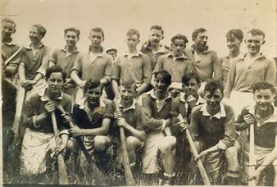

Hurling is Europe's oldest field game. It is played with a stick or "hurley" (called camán in Irish) which is curved outwards at the end, to provide the striking surface. The hurley is made from Ash. The ball or "sliothar" is made from leather.

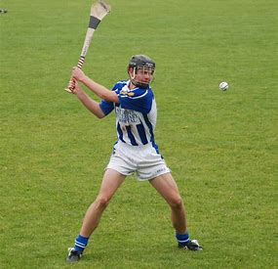
A sliotar or sliothar is a hard solid sphere slightly larger than a tennis ball, consisting of a cork core covered by two pieces of leather stitched together. Sometimes called a "dust" or "hurling ball", it resembles a baseball with more pronounced stitching.

Key points of hurling
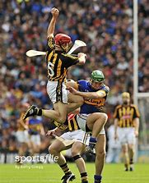
It is a stick and ball game, played by teams of 15 on a rectangular grass pitch with H-shaped goals at each end. The primary object is to score by driving the ball through the goals or putting the ball over the bar and thereby scoring a point. Three points is the equivalent of a goal.

Fun Facts

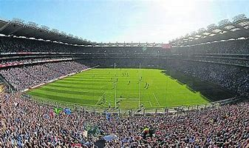
- Every year, over 82,000 people attend the All-Ireland Hurling Final (the Super Bowl of hurling) in Croke Park in Dublin.
- Hurling is considered to be the world’s oldest and fastest field sport with the ball being hit at speeds up to 100 mph.
- The word “puck” used in ice hockey is derived from the Irish word “poc” which refers to striking the ball with a hurl.

History of Limerick Hurlers

- They have won 93 championships.
- The title has been won by 13 different teams, 10 of whom have won the title more than once.
- The all-time record-holders are Kilkenny, who have won the championship on 36 occasions.
- Limerick are the current champions and after 45 years they won the all-Ireland last August.

